|  |
| --- |
| College LaSalle |
| Project - Oriented Object Programming User and Technical Manual |
|  |
| Presented to:Mihai Maftai |

|  |
| --- |
| Your name:Dhruvish Patel  8/1/2019 |

1. Start by adding a short description of your project, and the languages (technologies) used:
2. Language :c sharp
3. tool : Visual Studio 2017

Version 15.9.7

1. Present the print screens of yours forms, and have a detailed description of the functionalities (step by step).

1)Main Form=

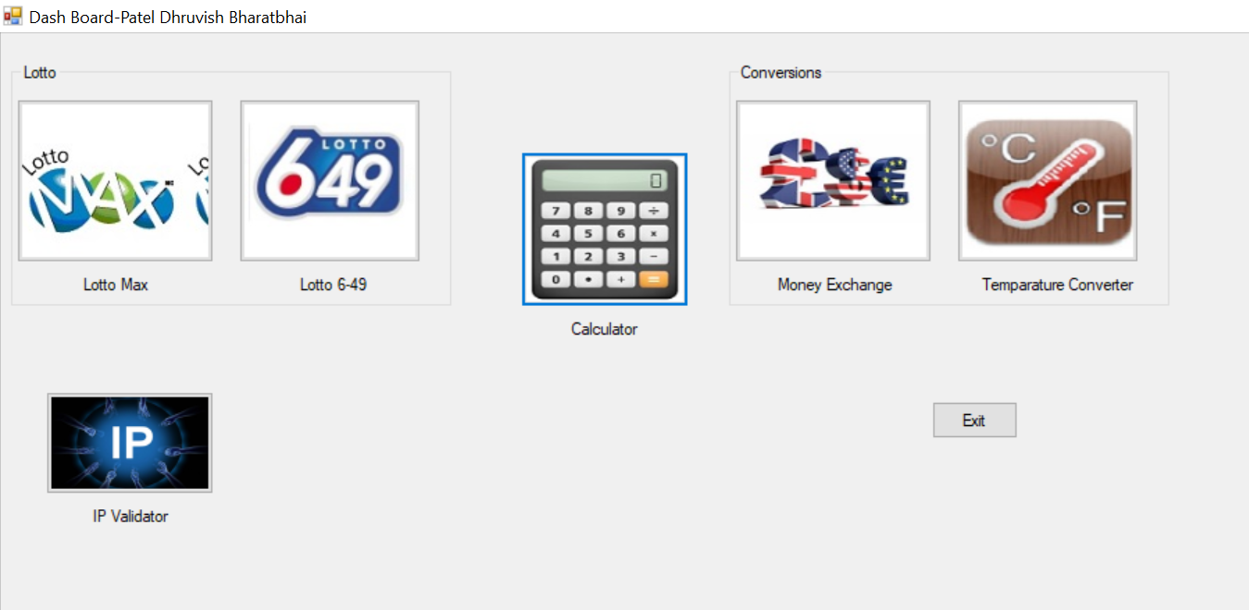

* If you click on the Lotto-Max, it will lead us to another form called lotto-Max.
* If you click on the Lotto-649, it will lead us to another form called lotto-649.
* If you click on the Calculator, it will lead us to another form called Calculator.
* If you click on the Money Exchange, it will lead us to another form called Money Exchange.
* If you click on the Temperature Converter, it will lead us to another form called Temperature Converter.
* If you click on the IP Validator, it will lead us to another form called lotto-Max., it will lead us to another form called lotto-Max.
* Exit button will exit the window.

2)Lotto-max:

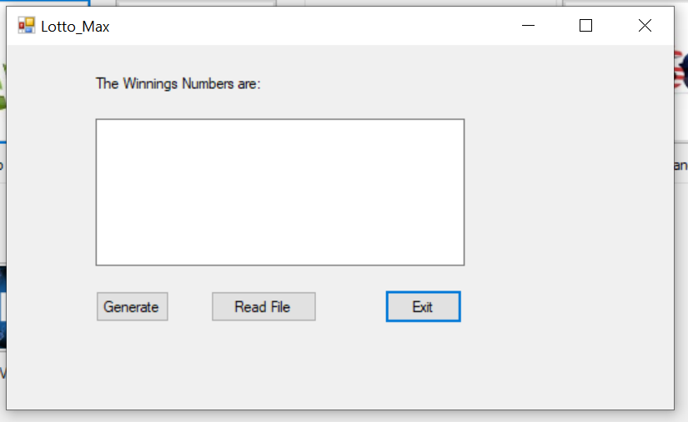

* After clicking on Generate button, Given text box show the random 7 numbers.
* Read button works like history, Whatever numbers are being generated , will be displayed here.
* Exit button asks you to Exit from this Window.

3)Lotto-649:

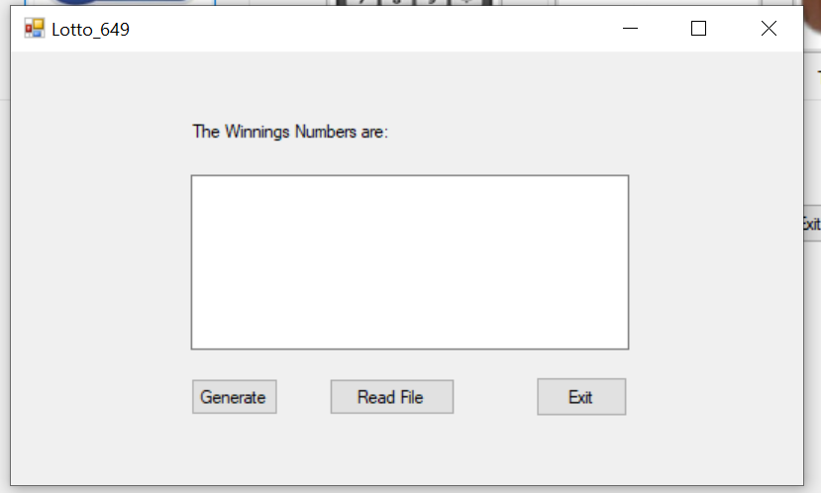

* After clicking on Generate button, Given text box show the random 6 numbers.
* Read button works like history, Whatever numbers are being generated , will be displayed here.
* Exit button asks you to Exit from this Window.

4)Calculator:

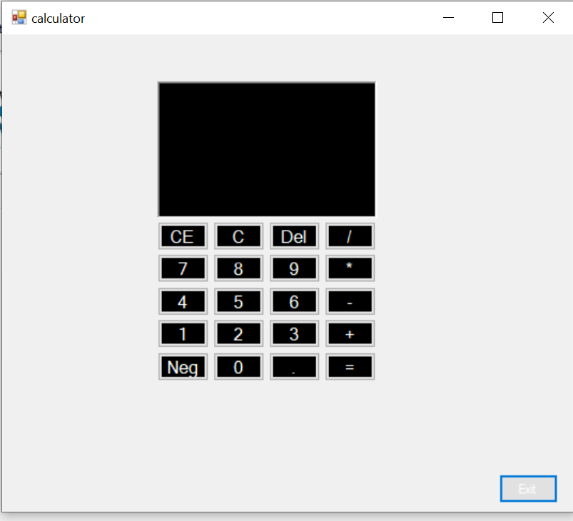

* By clicking on each button, It will displayed on the shown text box.
* + will add the numbers
* - will minus the numbers
* * will multiply the numbers
* / will divide the numbers
* But result will only be displayed after clicking = button
* CE and C both will clear the display
* Del will delete one number that you entered last
* We can check our history As I created a .txt file to save the history.
* Exit will Exit from the window

5)Money Exchange:

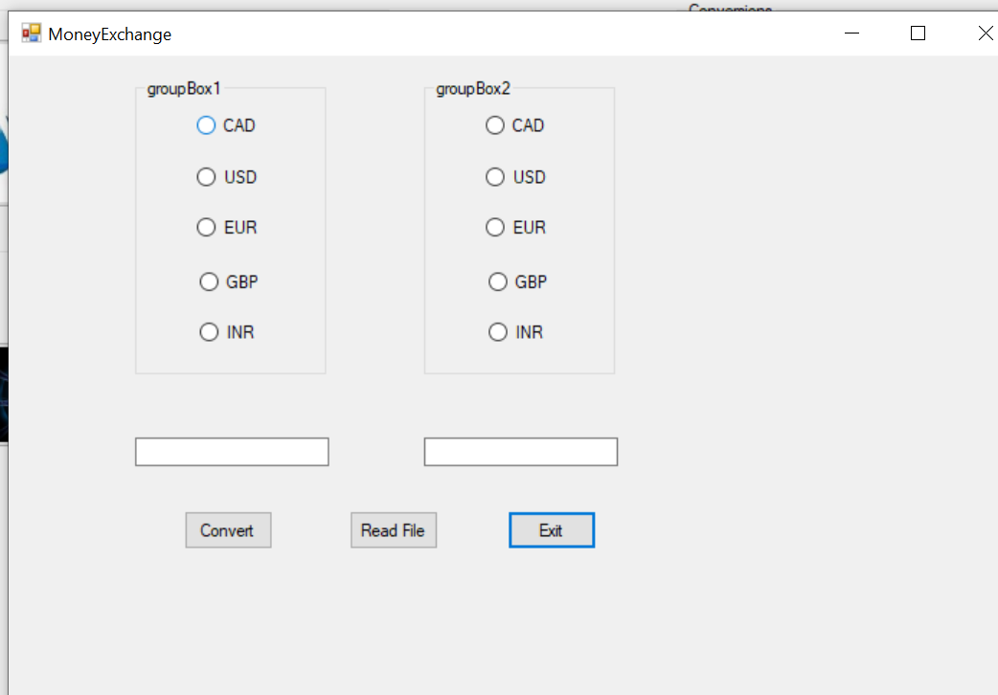

* Here two group are there
* First we need to enter the number we want to convert
* After entering the number We need to select the radio button (1 from 5) from Group Box 1
* Now select another radio button to convert that number
* After clicking the Convert button, Number will be converted to chosen format.
* Exit will exit the window
* Read button works like history, Whatever results are being generated , will be displayed here.

6)Temperature Converter:

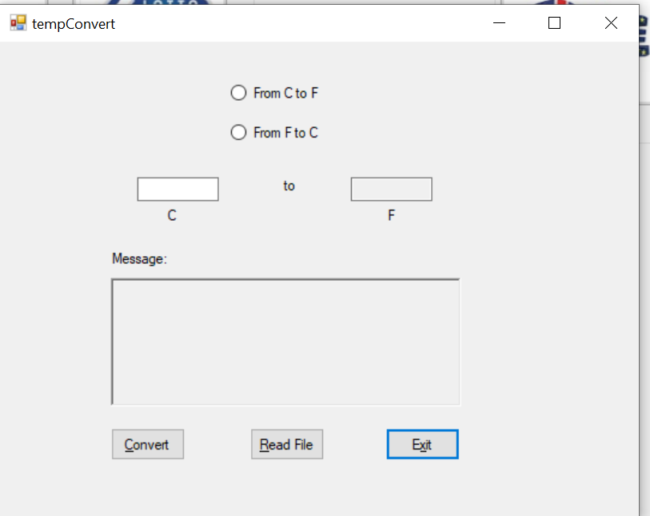

* First we need to enter the number we want to convert
* After entering the number we need to select the conversion
* If we are converting from C to F then label will be like C to F
* But if we are converting from the F to C then it will change the lable name like F to C
* Exit will exit the window
* Read button works like history, Whatever results are being generated , will be displayed here.

7)

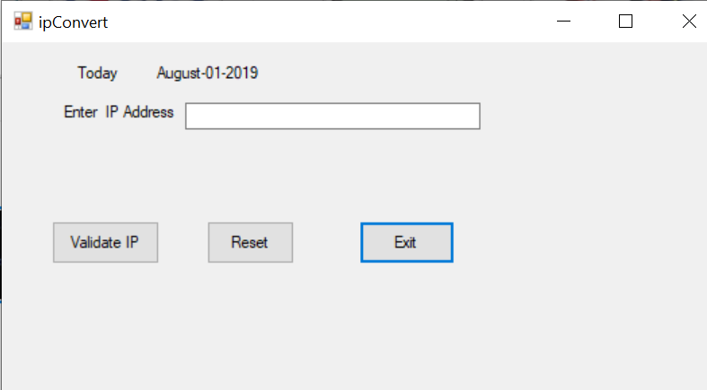

* Here this form will display currunt date and year
* First we need to enter the IP address
* After clicking the Validate IP button,If it is correct then it will show Correct IP otherwise error message.
* Reset will clear all the fields
* Exit will exit the window

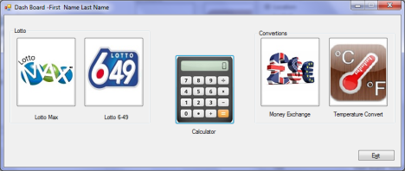

1. Present the code of your application (forms).

1)Main form:

using System;

using System.Collections.Generic;

using System.ComponentModel;

using System.Data;

using System.Drawing;

using System.Linq;

using System.Text;

using System.Threading.Tasks;

using System.Windows.Forms;

namespace WindowsFormsApp1

{

public partial class Form1 : Form

{

public Form1()

{

InitializeComponent();

}

private void button2_Click(object sender, EventArgs e)

{

tempConvert tc = new tempConvert();

tc.Show();

}

private void label1_Click(object sender, EventArgs e)

{

}

private void button4_Click(object sender, EventArgs e)

{

Lotto_649 lm2 = new Lotto_649();

lm2.Show();

}

private void button5_Click(object sender, EventArgs e)

{

Lotto_Max lm = new Lotto_Max();

lm.Show();

}

private void button3_Click(object sender, EventArgs e)

{

calculator cl = new calculator();

cl.Show();

}

private void button1_Click(object sender, EventArgs e)

{

MoneyExchange me = new MoneyExchange();

me.Show();

}

private void button7_Click(object sender, EventArgs e)

{

ipConvert ic = new ipConvert();

ic.Show();

}

private void button6_Click(object sender, EventArgs e)

{

Application.Exit();

}

private void Form1_Load(object sender, EventArgs e)

{

}

}

}

2)Lotto-Max:

using System;

using System.Collections.Generic;

using System.ComponentModel;

using System.Data;

using System.Drawing;

using System.Linq;

using System.Text;

using System.Threading.Tasks;

using System.Windows.Forms;

using System.IO;

namespace WindowsFormsApp1

{

public partial class Lotto_Max : Form

{

public Lotto_Max()

{

InitializeComponent();

}

private void lotto1Exit_Click(object sender, EventArgs e)

{

string str = "";

str = MessageBox.Show("Do You Want To Quit \n This Application?", "Exit?", MessageBoxButtons.YesNo).ToString();

if(str == "Yes")

{

this.Close();

}

}

int i;

private void button1_Click(object sender, EventArgs e)

{

int[] numbers = new int[7];

Random rand = new Random();

textBox1.Clear();

for (i = 0; i < numbers.Length; i++)

{

numbers[i] = rand.Next(1,49);

textBox1.Text += numbers[i].ToString() + Environment.NewLine;

}

File.AppendAllText("LottoNbrs.txt", "Max, " + DateTime.Now.ToString() + ", " + textBox1.Text + " " + Environment.NewLine);

}

private void listBox1_SelectedIndexChanged(object sender, EventArgs e)

{

}

private void button2_Click(object sender, EventArgs e)

{

MessageBox.Show(File.ReadAllText("LottoNbrs.txt"), "Read", MessageBoxButtons.OK);

}

private void Lotto_Max_Load(object sender, EventArgs e)

{

}

}

}

3)Lotto-649:

using System;

using System.Collections.Generic;

using System.ComponentModel;

using System.Data;

using System.Drawing;

using System.Linq;

using System.Text;

using System.Threading.Tasks;

using System.Windows.Forms;

using System.IO;

namespace WindowsFormsApp1

{

public partial class Lotto_649 : Form

{

public Lotto_649()

{

InitializeComponent();

}

private void lotto2Exit_Click(object sender, EventArgs e)

{

this.Close();

}

int i;

private void button1_Click(object sender, EventArgs e)

{

int[] numbers = new int[6];

Random rand = new Random();

textBox1.Clear();

for (i = 0; i < numbers.Length; i++)

{

numbers[i] = rand.Next(1, 49);

textBox1.Text += numbers[i].ToString() + Environment.NewLine;

}

File.AppendAllText("LottoNbrs.txt", "649, " + DateTime.Now.ToString() + ", " + textBox1.Text + " Extra 23" );

}

private void lotto1Exit_Click(object sender, EventArgs e)

{

string str = "";

str = MessageBox.Show("Do You Want To Quit \n This Application?", "Exit?", MessageBoxButtons.YesNo).ToString();

if (str == "Yes")

{

this.Close();

}

}

private void button2_Click(object sender, EventArgs e)

{

MessageBox.Show(File.ReadAllText("LottoNbrs.txt"), "Read File", MessageBoxButtons.OK);

}

private void Lotto_649_Load(object sender, EventArgs e)

{

}

}

}

4)Caculator:

using System;

using System.Collections.Generic;

using System.ComponentModel;

using System.Data;

using System.Drawing;

using System.Linq;

using System.Text;

using System.Threading.Tasks;

using System.Windows.Forms;

using System.IO;

namespace WindowsFormsApp1

{

public partial class calculator : Form

{

public calculator()

{

InitializeComponent();

}

double FirstNumber;

string Operation;

double SecondNumber;

double Result;

//class calc

//{

// //int num;

// //public int Num { get => num; set => num = value; }

// public int getNumber(int num)

// {

// //Num = num;

// return num;

// }

//}

private void calcExit_Click(object sender, EventArgs e)

{

this.Close();

}

//calc c = new calc();

private void button17_Click(object sender, EventArgs e)

{

if (textBox1.Text == "0" && textBox1.Text != null)

{

textBox1.Text = "1";

}

else

{

textBox1.Text = textBox1.Text + "1";

}

}

private void btntwo_Click(object sender, EventArgs e)

{

if (textBox1.Text == "0" && textBox1.Text != null)

{

textBox1.Text = "2";

}

else

{

textBox1.Text = textBox1.Text + "2";

}

}

private void btnthree_Click(object sender, EventArgs e)

{

if (textBox1.Text == "0" && textBox1.Text != null)

{

textBox1.Text = "3";

}

else

{

textBox1.Text = textBox1.Text + "3";

}

}

private void btnfour_Click(object sender, EventArgs e)

{

if (textBox1.Text == "0" && textBox1.Text != null)

{

textBox1.Text = "4";

}

else

{

textBox1.Text = textBox1.Text + "4";

}

}

private void btnfive_Click(object sender, EventArgs e)

{

if (textBox1.Text == "0" && textBox1.Text != null)

{

textBox1.Text = "5";

}

else

{

textBox1.Text = textBox1.Text + "5";

}

}

private void btnsix_Click(object sender, EventArgs e)

{

if (textBox1.Text == "0" && textBox1.Text != null)

{

textBox1.Text = "6";

}

else

{

textBox1.Text = textBox1.Text + "6";

}

}

private void btnseven_Click(object sender, EventArgs e)

{

if (textBox1.Text == "0" && textBox1.Text != null)

{

textBox1.Text = "7";

}

else

{

textBox1.Text = textBox1.Text + "7";

}

}

private void btneight_Click(object sender, EventArgs e)

{

if (textBox1.Text == "0" && textBox1.Text != null)

{

textBox1.Text = "8";

}

else

{

textBox1.Text = textBox1.Text + "8";

}

}

private void btnnine_Click(object sender, EventArgs e)

{

if (textBox1.Text == "0" && textBox1.Text != null)

{

textBox1.Text = "9";

}

else

{

textBox1.Text = textBox1.Text + "9";

}

}

private void btndiv_Click(object sender, EventArgs e)

{

FirstNumber = Convert.ToDouble(textBox1.Text);

textBox1.Text = "0";

Operation = "/";

}

private void btnmul_Click(object sender, EventArgs e)

{

FirstNumber = Convert.ToDouble(textBox1.Text);

textBox1.Text = "0";

Operation = "*";

}

private void txtBox1_TextChanged(object sender, EventArgs e)

{

}

private void btnsub_Click(object sender, EventArgs e)

{

FirstNumber = Convert.ToDouble(textBox1.Text);

textBox1.Text = "0";

Operation = "-";

}

private void btnadd_Click(object sender, EventArgs e)

{

FirstNumber = Convert.ToDouble(textBox1.Text);

textBox1.Text = "0";

Operation = "+";

}

private void btneql_Click(object sender, EventArgs e)

{

string dir = @"..\..\..\Project\";

string filePath = @"..\..\..\Project\Calculator.txt";

double wr = 0 ;

SecondNumber = Convert.ToDouble(textBox1.Text);

if (Operation == "+")

{

Result = (FirstNumber + SecondNumber);

textBox1.Text = Convert.ToString(Result);

wr = FirstNumber;

FirstNumber = Result;

}

if (Operation == "-")

{

Result = (FirstNumber - SecondNumber);

textBox1.Text = Convert.ToString(Result);

wr = FirstNumber;

FirstNumber = Result;

}

if (Operation == "*")

{

Result = (FirstNumber * SecondNumber);

textBox1.Text = Convert.ToString(Result);

wr = FirstNumber;

FirstNumber = Result;

}

if (Operation == "/")

{

if (SecondNumber == 0)

{

textBox1.Text = "Cannot divide by zero";

}

else

{

Result = (FirstNumber / SecondNumber);

textBox1.Text = Convert.ToString(Result);

wr = FirstNumber;

FirstNumber = Result;

}

}

if (!Directory.Exists(dir)) Directory.CreateDirectory(dir);

FileStream file = new FileStream(filePath, FileMode.Append, FileAccess.Write);

StreamWriter textOut = new StreamWriter(file);

textOut.WriteLine(wr.ToString() + " " + Operation + " " + SecondNumber + " = " + Result.ToString());

textOut.Close();

}

private void btnzero_Click(object sender, EventArgs e)

{

textBox1.Text = textBox1.Text + "0";

}

private void btnce_Click(object sender, EventArgs e)

{

textBox1.Text = "0";

}

private void btnc_Click(object sender, EventArgs e)

{

textBox1.Text = "0";

}

private void btndel_Click(object sender, EventArgs e)

{

string str = textBox1.Text;

int len = str.Length - 1;

textBox1.Text = str.Remove(len);

}

private void btndot_Click(object sender, EventArgs e)

{

textBox1.Text = textBox1.Text + ".";

}

private void calculator_Load(object sender, EventArgs e)

{

}

}

}

5)Money-Exchange:

using System;

using System.Collections.Generic;

using System.ComponentModel;

using System.Data;

using System.Drawing;

using System.Linq;

using System.Text;

using System.Threading.Tasks;

using System.Windows.Forms;

using System.IO;

namespace WindowsFormsApp1

{

public partial class MoneyExchange : Form

{

public MoneyExchange()

{

InitializeComponent();

}

private void moneyExit_Click(object sender, EventArgs e)

{

string str = "";

str = MessageBox.Show("Do You Want To Quit The Money Exchange Application?", "Exit?", MessageBoxButtons.YesNo).ToString();

if(str=="Yes")

{

this.Close();

}

}

private void radioButton1_CheckedChanged(object sender, EventArgs e)

{

}

moneyConvert con = new moneyConvert();

double n = 0;

private void button2_Click(object sender, EventArgs e)

{

try

{

n = Convert.ToDouble(from.Text);

con = new moneyConvert(n);

}

catch (Exception ex)

{

MessageBox.Show(ex.Message + "\n please enter new numeric value");

from.Focus();

from.Clear();

}

if(cad.Checked==true)

{

if(cad2.Checked==true)

{

to.Text = con.cadToCad().ToString();

}

else if(usd2.Checked == true)

{

to.Text = con.cadToUsd().ToString();

}

else if (eur2.Checked == true)

{

to.Text = con.cadToEur().ToString();

}

else if (gbp2.Checked == true)

{

to.Text = con.cadToGbp().ToString();

}

else if (inr2.Checked == true)

{

to.Text = con.cadToInd().ToString();

}

}

else if (usd.Checked == true)

{

if (cad2.Checked == true)

{

to.Text = con.usdToCad().ToString();

}

else if (usd2.Checked == true)

{

to.Text = con.usdTousd().ToString();

}

else if (eur2.Checked == true)

{

to.Text = con.usdToEur().ToString();

}

else if (gbp2.Checked == true)

{

to.Text = con.usdToGdp().ToString();

}

else if (inr2.Checked == true)

{

to.Text = con.usdToInr().ToString();

}

}

else if (eur.Checked == true)

{

if (cad2.Checked == true)

{

to.Text = con.eurToCad().ToString();

}

else if (usd2.Checked == true)

{

to.Text = con.eurToUsd().ToString();

}

else if (eur2.Checked == true)

{

to.Text = con.eurToEur().ToString();

}

else if (gbp2.Checked == true)

{

to.Text = con.eurToGbp().ToString();

}

else if (inr2.Checked == true)

{

to.Text = con.usdToInr().ToString();

}

}

else if (gbp.Checked == true)

{

if (cad2.Checked == true)

{

to.Text = con.gbpTocad().ToString();

}

else if (usd2.Checked == true)

{

to.Text = con.gbpToUsd().ToString();

}

else if (eur2.Checked == true)

{

to.Text = con.gbpToEur().ToString();

}

else if (gbp2.Checked == true)

{

to.Text = con.gbpTogbp().ToString();

}

else if (inr2.Checked == true)

{

to.Text = con.gbpToInr().ToString();

}

}

else if (inr.Checked == true)

{

if (cad2.Checked == true)

{

to.Text = con.indToCad().ToString();

}

else if (usd2.Checked == true)

{

to.Text = con.indToUsd().ToString();

}

else if (eur2.Checked == true)

{

to.Text = con.indToEur().ToString();

}

else if (gbp2.Checked == true)

{

to.Text = con.indToGbp().ToString();

}

else if (inr2.Checked == true)

{

to.Text = con.indToInd().ToString();

}

}

File.AppendAllText("MoneyConversions.txt","Read " + " " + con.Number + " = " + to.Text + " "+ DateTime.Now.ToString() + Environment.NewLine);

}

private void textBox1_TextChanged(object sender, EventArgs e)

{

}

private void button1_Click(object sender, EventArgs e)

{

MessageBox.Show(File.ReadAllText("MoneyConversions.txt"), "Read File", MessageBoxButtons.OK);

}

private void MoneyExchange_Load(object sender, EventArgs e)

{

}

}

public class moneyConvert

{

double number;

public double Number { get => number; set => number = value; }

public moneyConvert() { }

public moneyConvert(double n)

{

Number = n;

}

public double cadToUsd()

{

return number * 0.76;

}

public double cadToCad()

{

return number;

}

public double cadToEur()

{

return number*0.68;

}

public double cadToGbp()

{

return number*0.61;

}

public double cadToInd()

{

return number*52.58;

}

public double usdToCad()

{

return number * 1.31;

}

public double usdTousd()

{

return number;

}

public double usdToEur()

{

return number*0.49;

}

public double usdToGdp()

{

return number*0.80;

}

public double usdToInr()

{

return number*68.81;

}

public double eurToGbp()

{

return number*0.90;

}

public double eurToEur()

{

return number;

}

public double eurToCad()

{

return number*1.47;

}

public double eurToUsd()

{

return number*1.12;

}

public double eurToInr()

{

return number*77.24;

}

public double gbpToEur()

{

return number*1.11;

}

public double gbpTogbp()

{

return number;

}

public double gbpTocad()

{

return number*1.64;

}

public double gbpToUsd()

{

return number*1.25;

}

public double gbpToInr()

{

return number*86.12;

}

public double indToCad()

{

return number*0.019;

}

public double indToUsd()

{

return number * 0.015;

}

public double indToEur()

{

return number * 0.013;

}

public double indToGbp()

{

return number * 0.012;

}

public double indToInd()

{

return number;

}

}

}

6)Temperature Converter:

using System;

using System.Collections.Generic;

using System.ComponentModel;

using System.Data;

using System.Drawing;

using System.Linq;

using System.Text;

using System.Threading.Tasks;

using System.Windows.Forms;

using System.IO;

namespace WindowsFormsApp1

{

public partial class tempConvert : Form

{

public tempConvert()

{

InitializeComponent();

}

private void tempExit_Click(object sender, EventArgs e)

{

this.Close();

}

convertTemp con = new convertTemp();

double n = 0;

private void button2_Click(object sender, EventArgs e)

{

try

{

n = Convert.ToDouble(from.Text);

con = new convertTemp(n);

}

catch (Exception ex)

{

MessageBox.Show(ex.Message + "\n please enter new numeric value");

from.Focus();

from.Clear();

}

if(btn1.Checked==true)

{

to.Text = con.cToF().ToString();

label2.Text = "C";

label3.Text = "F";

File.AppendAllText("TempConversions.txt", from.Text + " C " + " = " + to.Text + " F," + DateTime.Now.ToString() + Environment.NewLine);

}

else if(btn2.Checked==true)

{

to.Text = con.fToC().ToString();

label2.Text = "F";

label3.Text = "C";

File.AppendAllText("TempConversions.txt", from.Text + " F " + " = " + to.Text + "C" + DateTime.Now.ToString() + Environment.NewLine);

}

}

private void tempConvert_Load(object sender, EventArgs e)

{

}

private void radioButton1_CheckedChanged(object sender, EventArgs e)

{

}

private void to_TextChanged(object sender, EventArgs e)

{

if(from.Text=="100")

{

if(btn2.Checked==true)

{

description.Clear();

}

else

{

description.Text = "Water Boils";

}

}

else if (from.Text == "40")

{

if (btn2.Checked == true)

{

description.Clear();

}

else

{

description.Text = "Hot Bath";

}

}

else if (from.Text == "37")

{

if (btn2.Checked == true)

{

description.Clear();

}

else

{

description.Text = "Body Temparature";

}

}

else if (from.Text == "30")

{

if (btn2.Checked == true)

{

description.Clear();

}

else

{

description.Text = "Beach Teamparature";

}

}

else if (from.Text == "21")

{

if (btn2.Checked == true)

{

description.Clear();

}

else

{

description.Text = "Room Temparature";

}

}

else if (from.Text == "10")

{

if (btn2.Checked == true)

{

description.Clear();

}

else

{

description.Text = "Cool Day";

}

}

else if (from.Text == "0")

{

if (btn2.Checked == true)

{

description.Clear();

}

else

{

description.Text = "Freezing Points";

}

}

else if (from.Text == "-18")

{

if (btn2.Checked == true)

{

description.Clear();

}

else

{

description.Text = "Very Cold Day";

}

}

else if (from.Text == "-40")

{

if (btn2.Checked == true)

{

description.Clear();

}

else

{

description.Text = "Extremely Cold Day";

}

}

else

{

description.Clear();

}

}

private void richTextBox1_TextChanged(object sender, EventArgs e)

{

}

private void button1_Click(object sender, EventArgs e)

{

MessageBox.Show(File.ReadAllText("TempConversions.txt"), "File", MessageBoxButtons.OK);

}

}

public class convertTemp

{

double number;

public double Number { get => number; set => number = value; }

public convertTemp() { }

public convertTemp(double n)

{

Number = n;

}

public double cToF()

{

return (Number * 1.8) + 32;

}

public double fToC()

{

return (Number - 32) / 1.8;

}

}

}

7)IP Validator:

using System;

using System.Collections.Generic;

using System.ComponentModel;

using System.Data;

using System.Drawing;

using System.Linq;

using System.Text;

using System.Threading.Tasks;

using System.Windows.Forms;

using System.Collections.Generic;

using System.Globalization;

using System.Text.RegularExpressions;

using System.IO;

namespace WindowsFormsApp1

{

public partial class ipConvert : Form

{

public ipConvert()

{

InitializeComponent();

}

private void ipExit_Click(object sender, EventArgs e)

{

this.Close();

}

private void button2_Click(object sender, EventArgs e)

{

textBox1.Text = "";

}

private void button1_Click(object sender, EventArgs e)

{

textBox1.Text = textBox1.Text.Trim();

if (!string.IsNullOrWhiteSpace(textBox1.Text))

{

Regex reg = new Regex(@"^(25[0-5]|2[0-4]\d|[0-1]?\d?\d)(\.(25[0-5]|2[0-4]\d|[0-1]?\d?\d)){3}$");

if (reg.IsMatch(textBox1.Text))

{

MessageBox.Show(textBox1.Text + "\nThe IP is correct");

}

else

{

MessageBox.Show("The IP must have 4 bytes\ninteger number between 0 to 255\nseperated by a dot(255.255.255.255)");

}

}

}

private void label3_Click(object sender, EventArgs e)

{

}

private void ipConvert_Load(object sender, EventArgs e)

{

DateTime currentDate = DateTime.Today;

DateTime.TryParse(label3.Text, out currentDate);

label3.Text = DateTime.Now.ToString("MMMM-dd-yyyy");

}

}

}

1. Present the classes and/or methods that you create or you did use in the project.

|  |  |
| --- | --- |
| **Class/Method Name** | **Description** |
| 1. public class convertTemp | I am providing a number here , and then I passed that number to methods  .  So I used that methods to convert my number to appropriate form. |
| 1. public double cToF() | This will convert the number from Celsius to fernhite. |
| 1. public double fToC() | This will convert the number from Fernhite to Celsius |
| 1. public class moneyConvert | I am providing a number here , and then I passed that number to methods  .  So I used that Methods to convert my number to appropriate form of money exchange. |
| 1. public double cadToUsd() | Convert number from CAD to USD |
| 1. public double cadToCad() | Convert number from CAD to CAD |
| 1. public double cadToEur() | Convert number from CAD to USD |
| 1. public double cadToGbp() | Convert number from CAD to GBP |
| 9 public double cadToInd() | Convert number from CAD to IND |
| 10 public double usdToCad() | Convert number from USD to CAD |
| 11 public double usdTousd() | Convert number from USD to USD |
| 12 public double usdToEur() | Convert number from USD to EUR |
| 13 public double usdToGdp() | Convert number from USD to GDP |
| 14 public double usdToInr() | Convert number from USD to INR |
| 15public double eurToGbp() | Convert number from EUR to GBP |
| 16  public double eurToEur() | Convert number from EUR to EUR |
| 17 public double eurToCad() | Convert number from EUR to CAD |
| 18 public double eurToUsd() | Convert number from EUR to USD |
| 19public double eurToInr() | Convert number from EUR to INR |
| 20 public double gbpToEur() | Convert number from GBP to EUR |
| 21 public double gbpTogbp() | Convert number from GBP to GBP |
| 22 public double gbpTocad() | Convert number from GBP to CAD |
| 23 public double gbpToUsd() | Convert number from GBP to USD |
| 24 public double gbpToInr() | Convert number from GBP to INR |
| 25 public double indToCad() | Convert number from INR to CAD |
| 26 public double indToUsd() | Convert number from INR to USD |
| 27 public double indToEur() | Convert number from INR to EUR |
| 28 public double indToGbp() | Convert number from INR to GBP |
| 29 public double indToInd() | Convert number from INR to INR |

1. Present the difficulties that you have, what was the hardest and the easiest part of your project.

Hardest part:

* All the reading and writing files portion in the Project
* Validate IP is little bit harder
* Try and Catch
* Lotto was challenging

Easiest part:

* Money Exchange
* Temperature converter
* Calculator are the easiest part.